Trizal Nurrizki Somantri

Kp.Sukarame Rt 03 Rw 01 Desa.Sindang Panon

Kec. Banjaran Kab. Bandung 40377

Bandung, november 8th 2018

To :

**Human Resources Department**

Dear Sir/Madam,

I am male, Single, 22 years old, and graduated from Panghegar Collage Bandung majoring hotel operation. I am young, high motivation, dynamic individual. I have a good knowledge and attitude.

I would be hard working and cooperate with supervision in your best team work or independently.

I have experiences in hospitality and able to work under pressure and confident.

I apply for getting a job as Room Boy in your company. I would be appreciating if you consider my resume.

Enclosed with curriculum vitae, photograph, and certificates. If there are any questions regarding other personal data, I would be grateful to give you more specific information on the interview.

I hope it might be suitable with your requirements, and would be any challenging join with your company.

Respectfully yours,

Trizal Nurrizki Somantri

**CURRICULUM VITAE**

**PERSONAL DATA**

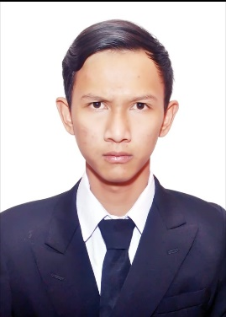

Name : TRIZAL NURRIZKI SOMANTRI

Sex : Male

Place/Date of Birth : Bandung, November 1st, 1996

Marital Status : SINGLE

Religion : Moslem

Height : 174 cm

Weight : 57 kg

Address : Kp.Sukarame Rt 03 Rw 01 Desa.Sindang Panon

Kec. Banjaran Kab. Bandung 40377

Telephone : 0895358628233/081320194923 (whatsapp)

Email : trizalnu34@gmail.com

**EDUCATION**

* Panghegar Collage Bandung Majored in Hotel Operational graduated 2017.
* Senior High School Negeri 1 Banjaran : 2012 - 2015
* Junior High School Negeri 1 Banjaran : 2009 - 2012
* Elementary school Negeri IX Banjaran : 2003 - 2009

**WORKING EXPERIENCES**

* Work at pt lumbung orbit kurnia in admin rolloff (march 08th , 2019 - january 22th ,2020 ).
* Work at Grand Setiabudi Hotel And Apartment in Housekeeping Department as Daily Worker ( June 20th,2017 – February 28th,2018).
* Work at Biro Pembayaran Listik as Accounting ( January 15th ,2017 – March 15th ,2017 ).
* Work at Gema Busana Banjaran as Staff warehouse ( July 1st ,2016 - July 30th ,2016 ).

**AWWARD AND APPRECIANTIONS**

* Certificate " PT Lumbung Orbit Kurnia ".
* Certificate “ To Whom It May Concern “ from Grand Setiabudi Hotel and Apartment.
* Certificate Seminar “ Sosialisasi sertifikat kompetensi bidang perhotelan dan kapal pesiar dari BNSP – LSP – CKPNI Jakarta “